
International School

Capstone Project 2
CMU-SE 451

Architecture Design
Version 1.1
Date: 10/05/2023

TICKET BOOKING AND SCHEDULE TRACKING SYSTEM

Submitted by

Trinh, Nguyen Thi My
Huy, Nguyen Huu
Bao, Huynh Viet
Do, Nguyen Van
Viet, Tran Hung

Approved by MSC, Thuan, Nguyen Tan

Architecture Review Panel Representative:
Name Signature Date

Capstone Project 2 - Mentor:
Name Signature Date

PROJECT INFORMATION
Project Acronym | TSBooking
Project Title | Ticket Booking and Schedule Tracking System
Start Date | March 10, 2023 | End Date | May 25, 2023
Lead Institution | International School, Duy Tan University
Project Mentor | MSC, Thuan, Nguyen Tan  Email: thuannt.it.dtu@gmail.com  Tel: 0905626276
Scrum Master / Project Leader & contact details | Do, Nguyen Van  Email: donguyen2801@gmail.com  Tel: 0392219299
Partner Organization | Duy Tan University
Project Web URL
Team Members | Name | Email | Tel
24201208432 | Trinh, Nguyen Thi My | nguyenthimytrinh1610@gmai.com | 0378343128
2321122721 | Huy, Nguyen Huu | huynguyen291098@gmail.com | 0905067246
25211203997 | Bao, Huynh Viet | baohuynhviet145@gmail.com | 0795537477
25211603690 | Viet, Tran Hung | thviet2001@gmail.com | 0935361065

REVISION HISTORY
Version | Date | Comments | Author | Approval
1.0 | 01/04/2023 | Initial Release | C2SE.34
1.1 | 10/05/2023 | Modify | C2SE.34

DOCUMENT APPROVALS
The following signatures are required for approval of this document.
MSC, Thuan, Nguyen Tan  Mentor |  | Date
Do, Nguyen Van  Scrum master |  | Date
Trinh, Nguyen Thi My  Product Owner |  | Date
Huy, Nguyen Huu Dev Team |  | Date
Bao, Huynh Viet  Dev Team |  | Date
Viet, Tran Hung  Dev Team |  | Date

Contents
1. Introduction 1
1.1. Purpose 1
1.2. Scope 1
1.3. List of User Interface 1
2. Describe User Interface for User 4
2.1. UI-01: Home page 4
4
2.2. UI-02: Register 5
2.3. UI-03: Login 6
2.5. UI-04: Logout 7
2.6. UI-05: View trip list 8
2.7. UI-06: Filter 9
2.8. UI-07: Choose a trip 10
2.9. UI-08: Select a seat 11
2.10. UI-09: Choose pick up point 12
2.14. UI-12: Trip information 15
3. Describe User Interface for Admin 17
3.1. UI-20: Login 17
3.2. UI-21: Logout 18
3.3. UI-22: View users list 19
3.4. UI-23: Edit user 20
3.5. UI-24: Ticket management 21
3.6. UI-25: Station management 21
3.7. UI-26: Trip management 22
3.9. UI-28: Add passenger 23
3.10. UI-29: Add vehicle 24
3.11. UI-30: Vehicle management 25
3.12. UI-31: Remove vehicle 26

- Introduction
  - Purpose
- This document describes the design interface of “Online Coach Ticket Booking System”
  - Scope
- Create complete interfaces, and describe them clearly.
- Overview of the stages and modules of the system
  - List of User Interface

Roles | User Interface ID | UI Name | Description
User | UI-01 | Home page | This form is used for the user to view home page
User | UI-02 | Register | This form is used for the user to register an account
User | UI-03 | Login | This form is used for the user to login into the system
User | UI-04 | Logout | This form is used for the user to logout into the system
User | UI-05 | View trip list | This form is used for the user can see the list of trips
User | UI-06 | Filter | This form is used for the user can filter trips by desired criteria
User | UI-07 | Choose a trip | This button can used for the user can choose the suitable trip
User | UI-08 | Select a seat | This form can be user for the user can choose a suitable seat
User | UI-09 | Select pick up point | This form can be user for the user can choose a suitable pick up point
User | UI-10 | Enter personal information | This form can be user for the user can enter personal information (name, phone number, ...)
User | UI-11 | Select payment methods | This form can be used for the user can choose payment methods (MoMo)
User | UI-12 | Trip information | This form can be used so that users can view their trip information
Admin | UI-20 | Login | This form is used for the admin to login into the system
Admin | UI-21 | Logout | This form is used for the admin to logout into the system
Admin | UI-22 | View users list | This form is used so that admin can view and manage a list of users
Admin | UI-23 | Edit user | This form is used so that admin can edit user
Admin | UI-24 | Ticket management | This form is used so that the admin can edit the ticket details
Admin | UI-25 | Passenger management | This form is used so that the admin can edit the Passenger details
Admin | UI-26 | Station management | This form is used so that the admin can edit the Station details
Admin | UI-27 | Add station | This form is used so that admin can add station
Admin | UI-28 | Add passenger | This form is used so that admin can add passenger
Admin | UI-29 | Add vehicle | This form is used so that admin can add vehicle
Admin | UI-30 | Vehicle management | This form is used so that the admin can edit the vehicle details
Admin | UI-31 | Remove vehicle | This form is used so that the admin can view the details of the coach
Admin | UI-32 | Ticket management | This form is used so that the admin can edit the ticket details

- Describe User Interface for User
  - UI-01: Home page
2
1

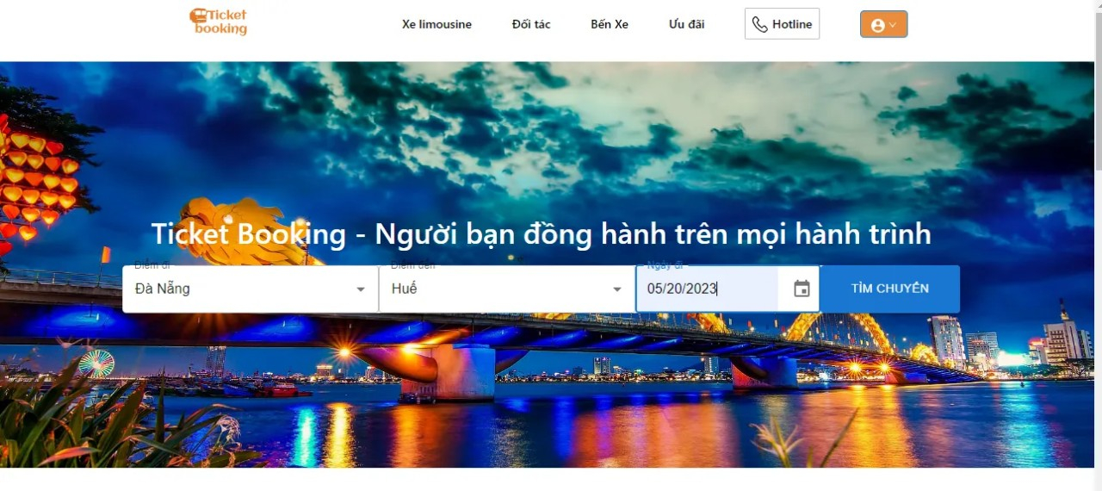
4
3

From | Condition | Null | Control Type | Target | Notes
1 | Nothing |  | Logo
2 | Click |  | Tab navigation | For site navigation
3 | Click |  | Search
4 | Nothing |  | Background Image

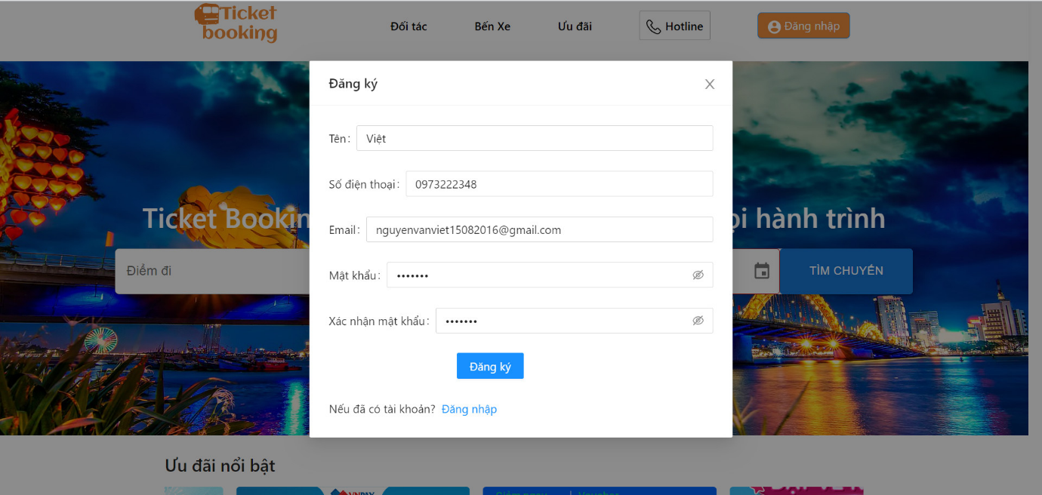
  - UI-02: Register
5
4
3
2
1

From | Condition | Null | Control Type | Target | Notes
1 | Input |  | Textbox | Input the information in the field to Register
2 | Click |  | Buttom | Click to register
3 | Click |  | Button | Click to go to login page
4 | Click |  | Button | Click to view password
5 | Click |  | Button | Click to exit

  - UI-03: Login
2
1
3
5
4
6
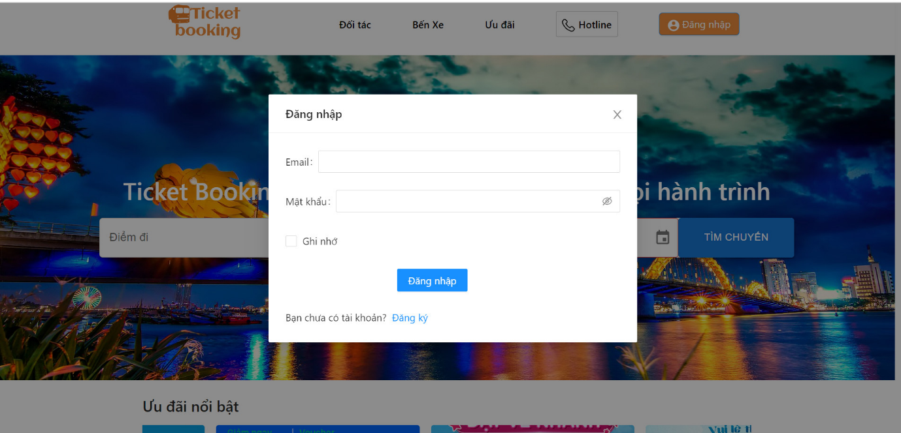

From | Condition | Null | Control Type | Target | Notes
1 | Input |  | Textbox | Input the information in the field to login
2 | Click |  | Button | Click to save login information
3 | Click |  | Button | Click to view password
4 | Click |  | Button | Click to login
5 | Click |  | Button | Click to go to registration page
6 | Click |  | Button | Click to exit

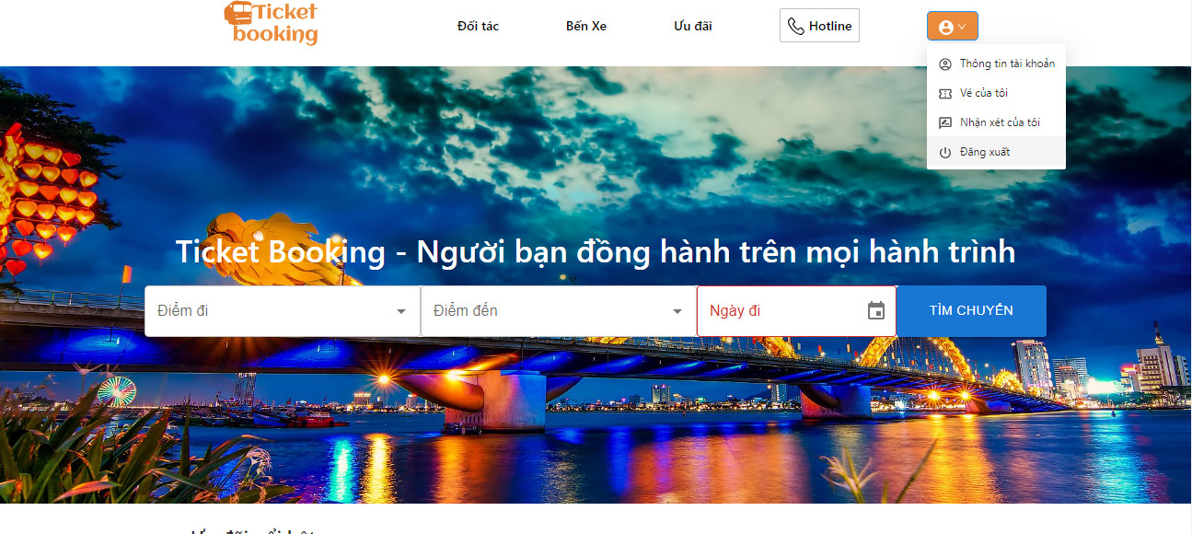
  - UI-04: Logout
4
5
3
2
1

From | Condition | Null | Control Type | Target | Notes
1 | Click |  | Button | Click to show a box to logout, view account information, view ticket
2 | Click |  | Button | Click to account information
3 | Click |  | Button | Click to view ticket
4 | Click |  | Button | Click to my comment
5 | Click |  | Button | Click to logout

  - UI-05: View trip list
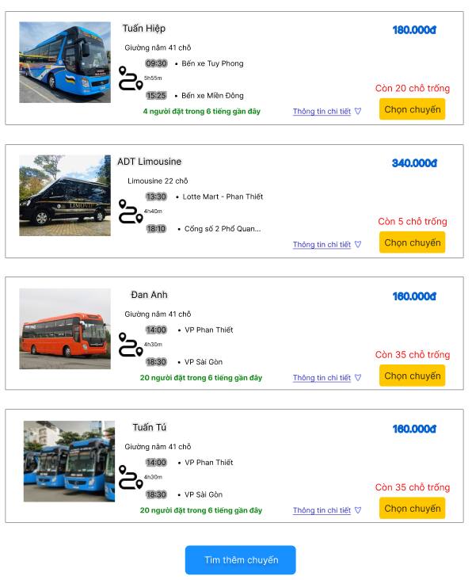
1
2
3
4

From | Condition | Null | Control Type | Target | Notes
1 | Nothing |  | Image | Picture of coach
2 | Nothing |  | Icon | Price of the trip
3 | Click |  | Button | Click to choose a trip
4 | Nothing |  | Text | Information of the trip

  - UI-06: Filter
1
2
4
3
5
6
7
8
10
9
12
11
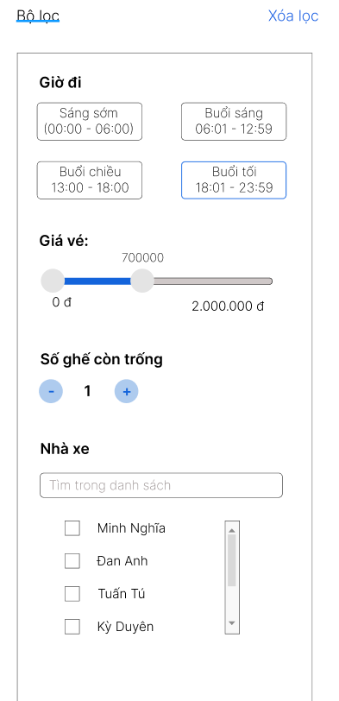

From | Condition | Null | Control Type | Target | Notes
1 | Nothing |  | Text | Nothing
2 | Click |  | Button | Click to clear all filters
3 | Nothing |  | Text | Show filter display is time
4 | Button |  | Click | Click to filter by time
5 | Nothing |  | Text | Show filter display is fare
6 | Drag the mouse |  | Range slider | Drag the mouse to the location to filter by price
7 | Nothing |  | Text | Show filter is the number of empty seats
8 | Click |  | Selection | Click to choose the number of emty seats
9 | Nothing |  | Text | Show filter is the coach
10 | Input |  | Textbox | Input the coach
11 | Click |  | Button | Click to choose the coach you want
12 | Drag the mouse |  | Slider | Drag the mouse to see more coaches

  - UI-07: Choose a trip
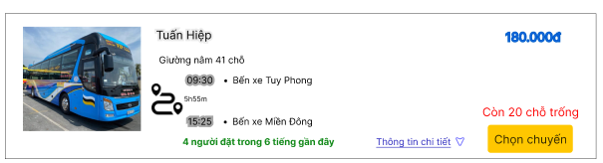
1

From | Condition | Null | Control Type | Target | Notes
1 | Click |  | Button | Click to choose a ride

  - UI-08: Select a seat
1
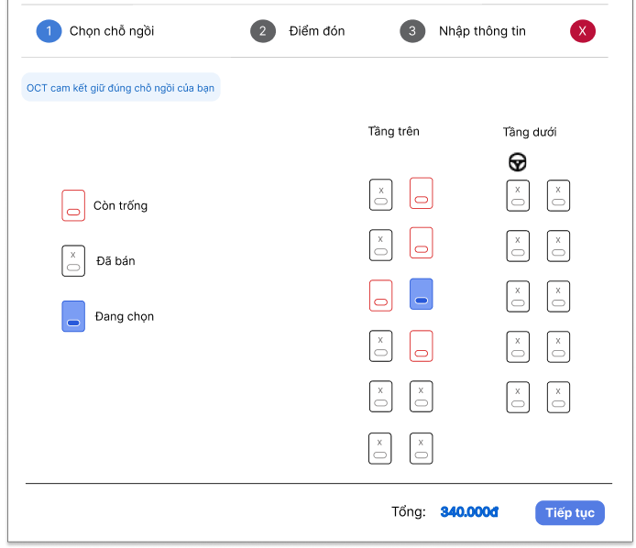
2
3
5
7
6
4
From | Condition | Null | Control Type | Target | Notes
1 | Nothing |  | Selection | Show current step
2 | Click |  | Button | Click to exit the current step
3 | Nothing |  | Text | Show OCT's commitment
4 | Nothing |  | Box | Show seat status (empty, sold, selected)
5 | Click |  | Selection | Click to select a seat
6 | Nothing |  | Text | Show total fare
7 | Click |  | Button | Click to next step

  - UI-09: Choose pick up point
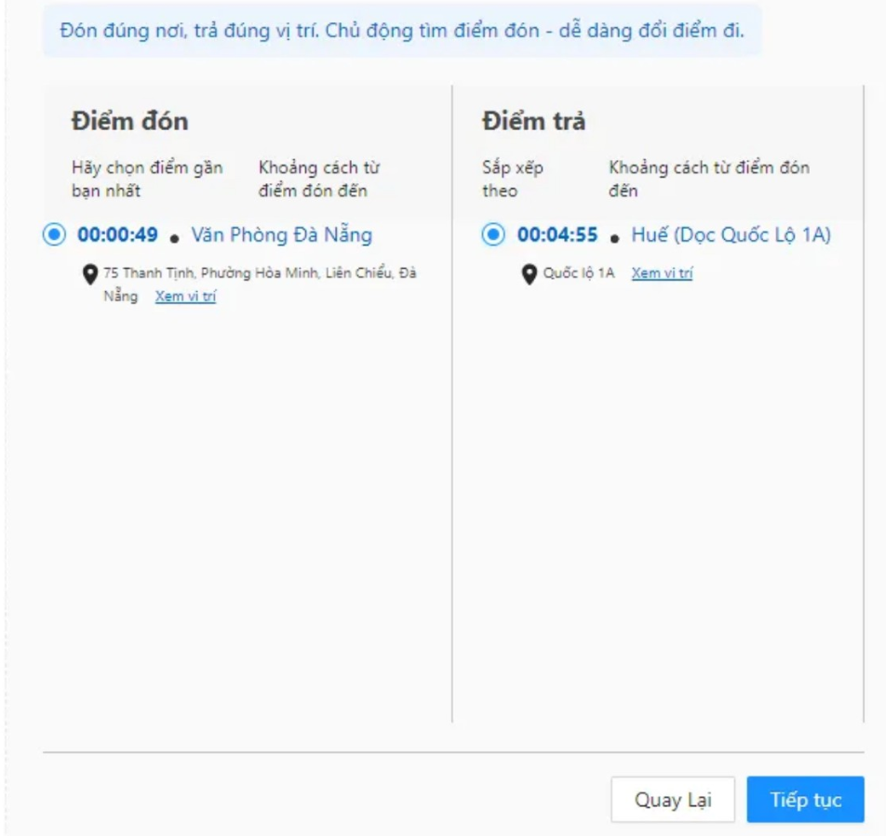
5
6
4
2
3
1

From | Condition | Null | Control Type | Target | Notes
1 | Nothing |  | Text | Pick-up point
2 | Nothing |  | Text | Drop-off point
3 | Click |  | Button | Click to choose pick up point
4 | Click |  | Button | Click to select drop-off point
5 | Click |  | Button | Click to see the location of the pick-up point
6 | Click |  | Button | Click to see the location of the drop-off point

  - UI-10: Enter personal information
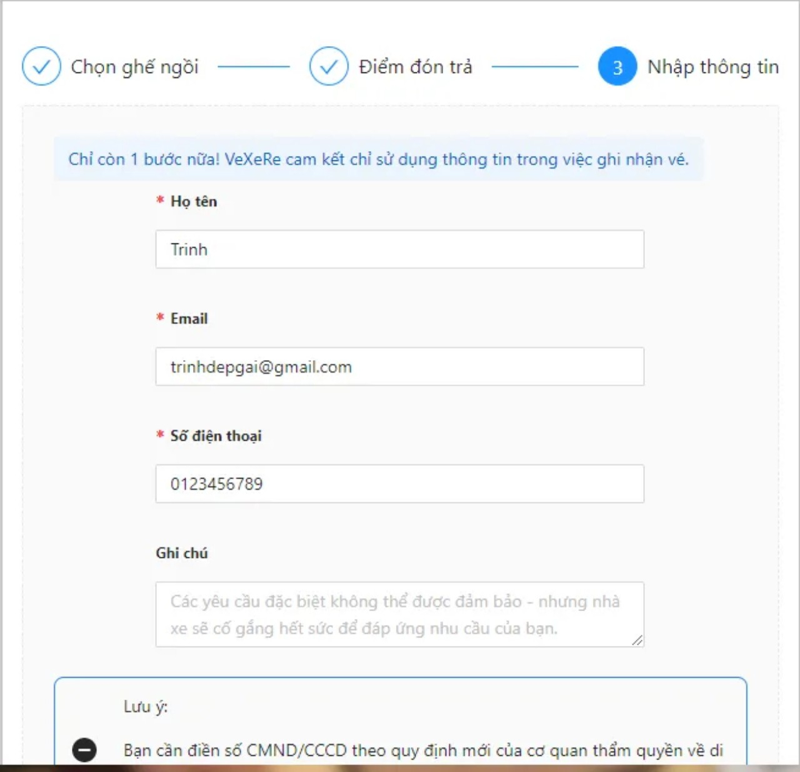
1
4
3
2

From | Condition | Null | Control Type | Target | Notes
1 | Input |  | Textbox | Click to enter first and last name
2 | Input |  | Textbox | Click to enter email
3 | Input |  | Textbox | Click to enter phone number
4 | Input |  | Textbox | Click to enter note (if any)

  - UI-11: Payment methods
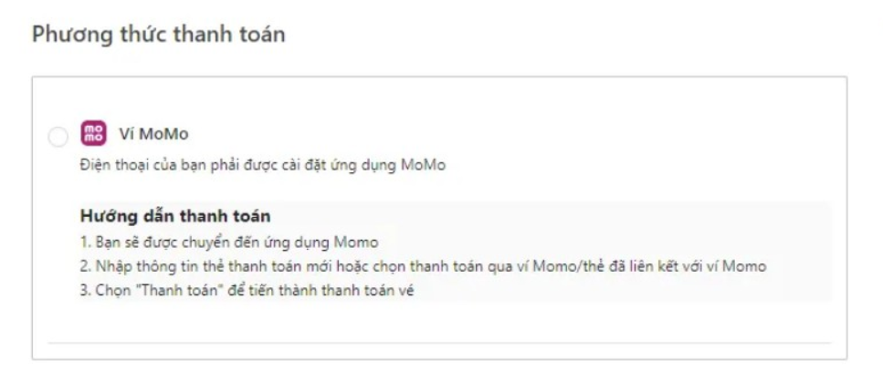
3
4
From | Condition | Null | Control Type | Target | Notes
3 | Nothing |  | Text
4 | Click |  | Selection | Click to select a payment method

  - UI-12: Trip information
1
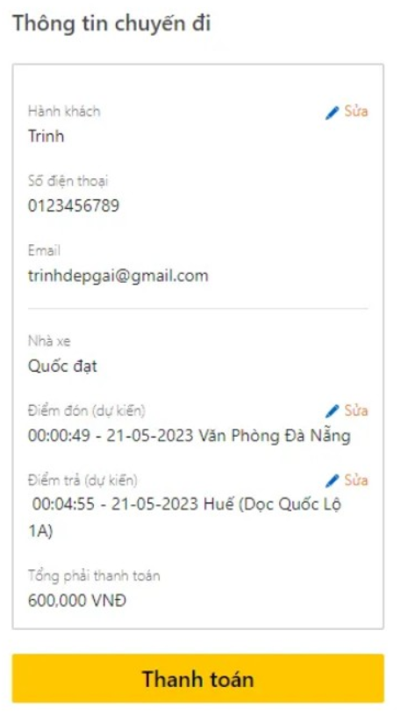
6
5
4
3
2
From | Condition | Null | Control Type | Target | Notes
1 | Nothing |  | Text
2 | Nothing |  | Text | Show trip information
3 | Click |  | Button | Click to edit customer name
4 | Click |  | Button | Click to edit pick-up location
5 | Click |  | Button | Click to edit drop off location

- Describe User Interface for Admin
  - UI-20: Login
From | Condition | Null | Control Type | Target | Notes
1 | Input |  | Textbox | Input the information in the field to login
2 | Click |  | Button | Click to save login information
3 | Click |  | Button | Click to view password
4 | Click |  | Button | Click to login
5 | Click |  | Button | Click to go to registration page
6 | Click |  | Button | Click to exit

  - UI-21: Logout
From | Condition | Null | Control Type | Target | Notes
1 | Click |  | Button | Click to show a box to logout, view account information, view ticket
2 | Click |  | Button | Click to account information
3 | Click |  | Button | Click to view ticket
4 | Click |  | Button | Click to my comment
5 | Click |  | Button | Click to logout

  - UI-22: View users list
5
6
4
2
3
1
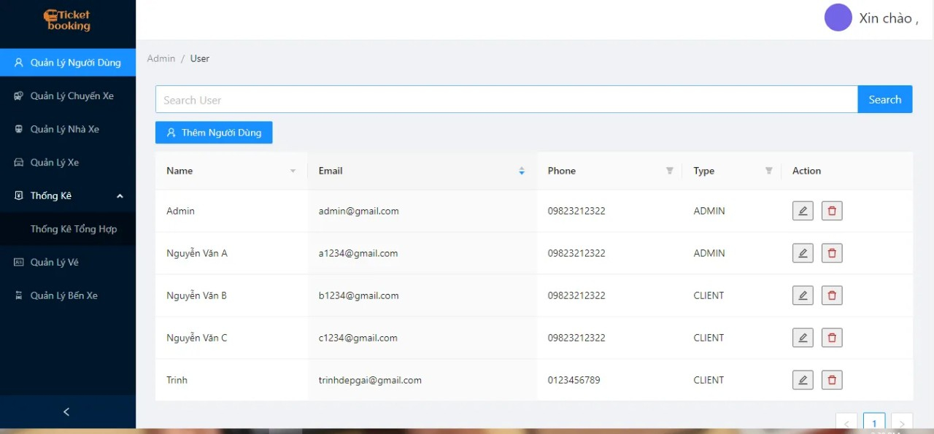
1
2
From | Condition | Null | Control Type | Target | Notes
1 | Click |  | Button | Click view users list
2 | Input |  | Textbox | Enter the information you are looking for
3 | Click |  | Buttom | Click to search
4 | Nothing |  | Text | View users list
5 | Click |  | Buttom | Click to edit
6 | Click |  | Buttom | Click to remove

  - UI-23: Edit user
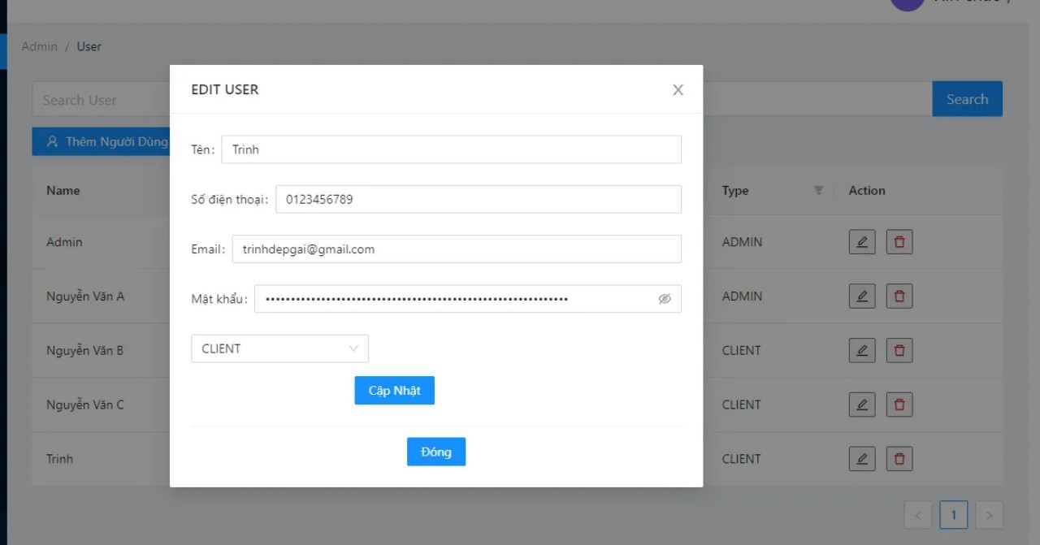
6
5
4
3
2
1

From | Condition | Null | Control Type | Target | Notes
1 | Input |  | Textbox | Enter to edit email
2 | Input |  | Textbox | Enter to edit phone
3 | Input |  | Textbox | Enter to edit email
4 | Input |  | Textbox | Enter to edit password
5 | Click |  | Button | Click to update
6 | Click |  | Button | Click to exit

  - UI-24: Ticket management
2
1
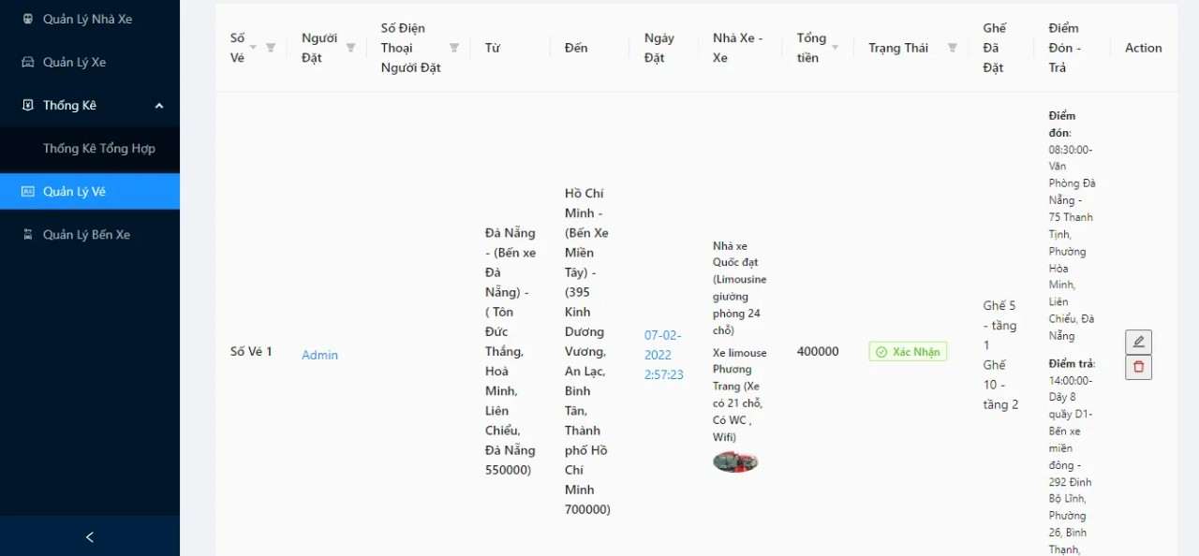
1
From | Condition | Null | Control Type | Target | Notes
1 | Click |  | Button | Click to ticket management
2 | Nothing |  | Text | View tickets list

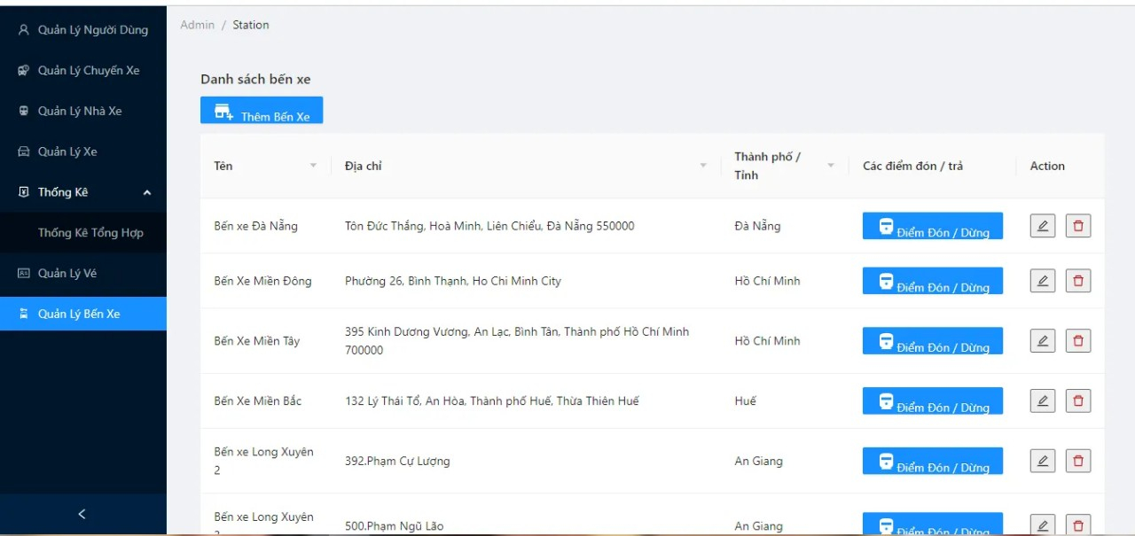
  - UI-25: Station management
4
3
2
1

From | Condition | Null | Control Type | Target | Notes
1 | Click |  | Button | Click to station management
2 | Nothing |  | View | List of station
3 | Click |  | Buttom | Click to edit
4 | Click |  | Buttom | Click to remove

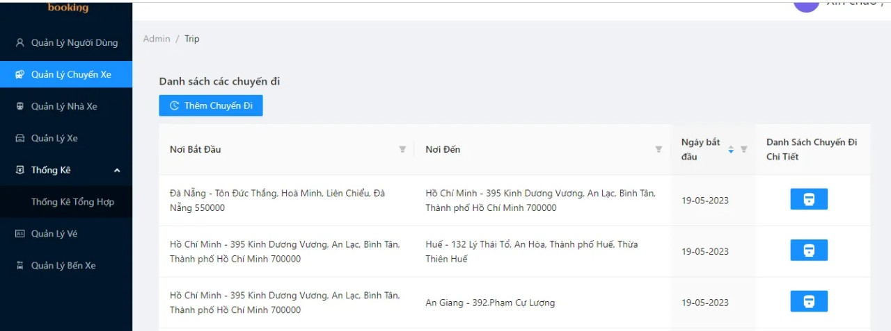
  - UI-26: Trip management
3=3
2
1

From | Condition | Null | Control Type | Target | Notes
1 | Click |  | Button | Click to add trip
2 | Nothing |  | Text | View trips list
3 | Click |  | Button | Click to detailed list of trips

  - UI-27: Add station
3
2
1
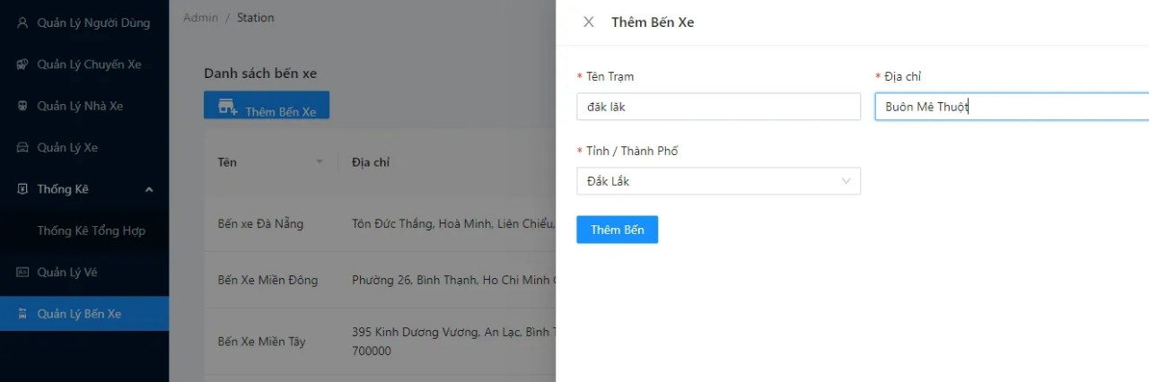
From | Condition | Null | Control Type | Target | Notes
1 | Input |  | Textbox | Add name station
2 | Input |  | Textbox | Add name address
3 | Input |  | Textbox | Add name province/city

  - UI-28: Add passenger
6
5
4
3
1
2
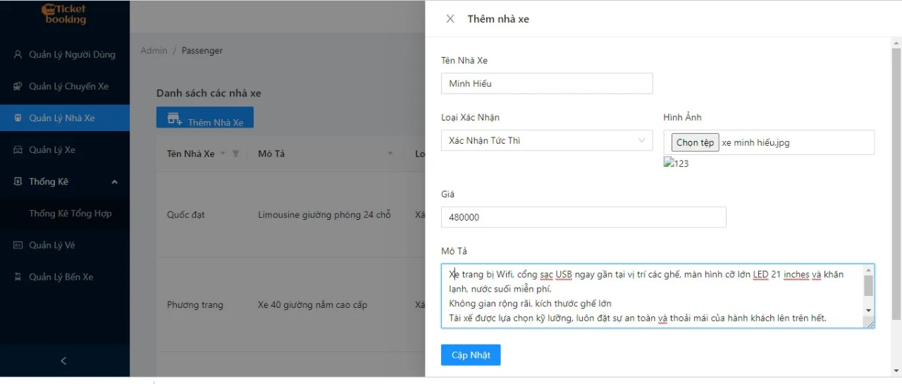
From | Condition | Null | Control Type | Target | Notes
1 | Input |  | Textbox | Enter the name passenger
2 | Input |  | Textbox | Confirmation type
3 | Click |  | Buttom | Choose a photo for passenger
4 | Input |  | Textbox | Enter the price of the trip
5 | Input |  | Textbox | Describe
6 | Click |  | Buttom | Add passenger

  - UI-29: Add vehicle
5
5
4
3
2
1
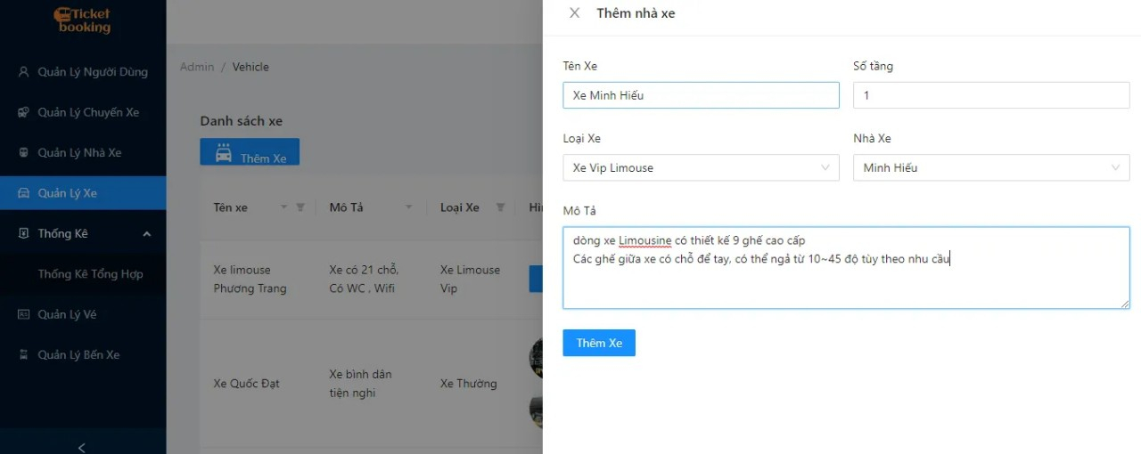

From | Condition | Null | Control Type | Target | Notes
1 | Input |  | Textbox | Enter the name vehicle
2 | Input |  | Textbox | Enter number of floors
3 | Input |  | Textbox | Enter range of vehicle
4 | Input |  | Textbox | Enter the name passenger
5 | Input |  | Textbox | Describe
6 | Click |  | Buttom | Add vehicle
  - UI-30: Vehicle management
5
4
3
2
1
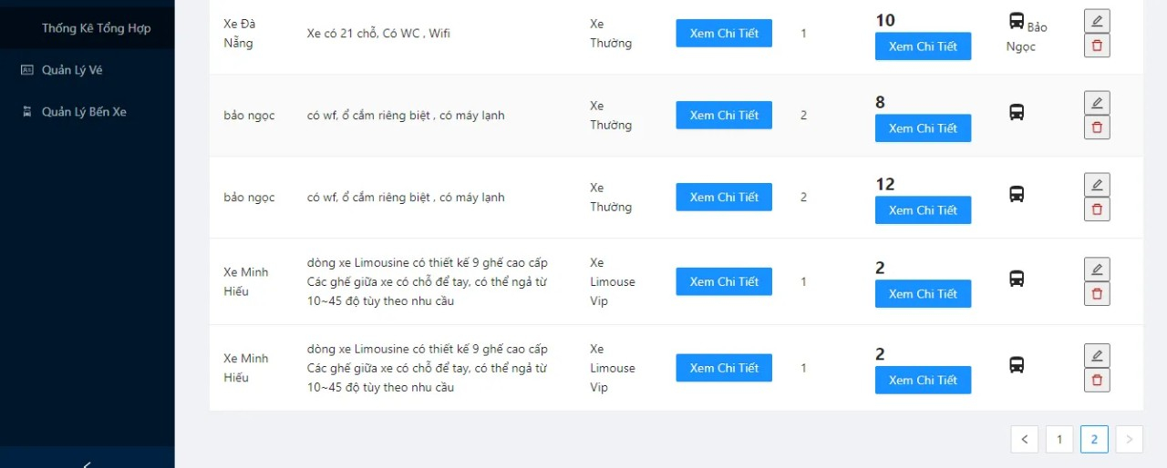

From | Condition | Null | Control Type | Target | Notes
1 | Click |  | Button | Click to see details
2 | Click |  | Button | Click to see details
3 | Click |  | Button | Click to edit vehicle
4 | Click |  | Button | Click to remove vehicle
5 | Click |  | Button | Click to next page

  - UI-31: Remove vehicle
1
2
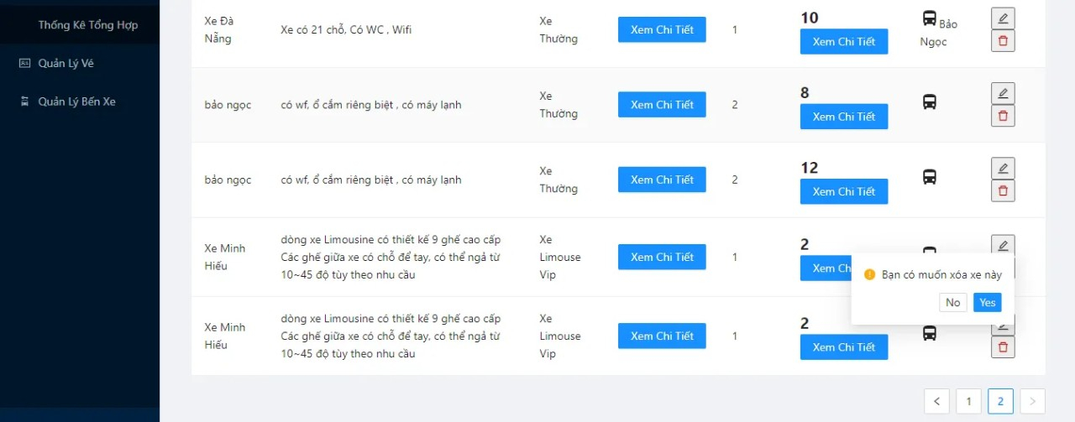

From | Condition | Null | Control Type | Target | Notes
1 | Click |  | Button | Click to exit
2 | Click |  | Button | Click to delete vehicle

